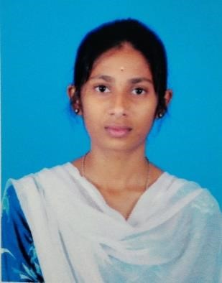**MOUNIKA M**

Email : mounikavin123@gmail.com

LinkedIn: <https://www.linkedin.com/in/mounika-m-2b37bb257/>

GitHub:<https://github.com/Mounikavin>

Leetcode:<https://leetcode.com/u/Mouni2108/>

Contact : 9842182000

**CAREER OBJECTIVE:**

To secure a challenging position in a dynamic organization where I can apply my skills

and academic knowledge, grow professionally, and contribute to the success of the company.

**EDUCATIONAL QUALIFICATION:**

|  |  |  |  |
| --- | --- | --- | --- |
| **DEGREE** | **NAME OF INSTITUTION** | **YEAR OF PASSING** | **PERCENTAGE/CGPA** |
| B.E Computer Science And Design | Karpagam Academy Of Higher Education. | Pursing | 9.07 |
| HSC | Vani Vidyalaya Matric Higher Secondary School. | 2022 | 84.3 |
| SSLC | Vani Vidyalaya Matric Higher Secondary School. | 2020 | 90.8 |

**INTERNSHIP:**

* Interned at “**ETHER INFOTECH”** as **python Developer** for duration of 10 days.
* ***Learning Outcome****:* Gain proficiency in Python programming to develop scalable applications, and solve real world problems using core libraries and frameworks.

**PROJECT:**

* **Title**  : “**TIC TAC TOE GAME**”

**Duration** : 7 weeks.

**Abstract** : To develop an interactive “**Tic Tac Toe”** game with a user-friendly **Graphical UserInterface** **(GUI)** that allows two players (or a player against the computer) to play seamlessly. The game will focus on simplicity, functionality, and visual appeal while providing a fun and engaging experience.

**AREA OF INTEREST:**

* Web based Game Development.
* Full Stack Development.
* UX Design.

**TECHNICAL SKILL:**

Programming Language :

* C
* C++
* Java .

Web Development :

* HTML,
* CSS.

Software Tools :

* MS Word,
* PowerPoint.

**CERTIFCATION:**

* Certified in “ **HTML,CSS** ” by ETHER INFOTECH a 1 day WorkShop.
* Certified in “**AI SOFTWARE ENGINEERING**” by INFOSYS.
* Certified in “**C PROGRAMMING”** from INFOSYS.

**PERSONALITY TRAITS:**

* Innovative.
* Empowered Leader.

**PERSONAL DETAILS:**

Date Of Birth :21/06/2004

Father’s Name :Manivannan M

Address : Sona Garden,Verapampalayam.

**DECLARATION:**

I hereby declare that the above information is true and correct to the best of my knowledge and belief.

**DATE:**

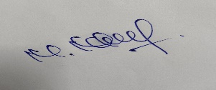**PLACE :**

**SIGNATURE**